4.1 Plan Management Tool
SeeNowDo will be used to monitor project approach, user stories, sprint plans, and development progress. Meanwhile, burn-down chart is provided to indicate whether the project is meeting its target schedule and budget.

- URL to login SeeNowDo:
https://www.seenowdo.com/pages/login/index.xhtml

- Project Name: OEE(Android)

- Image of project & iterations (sprints)
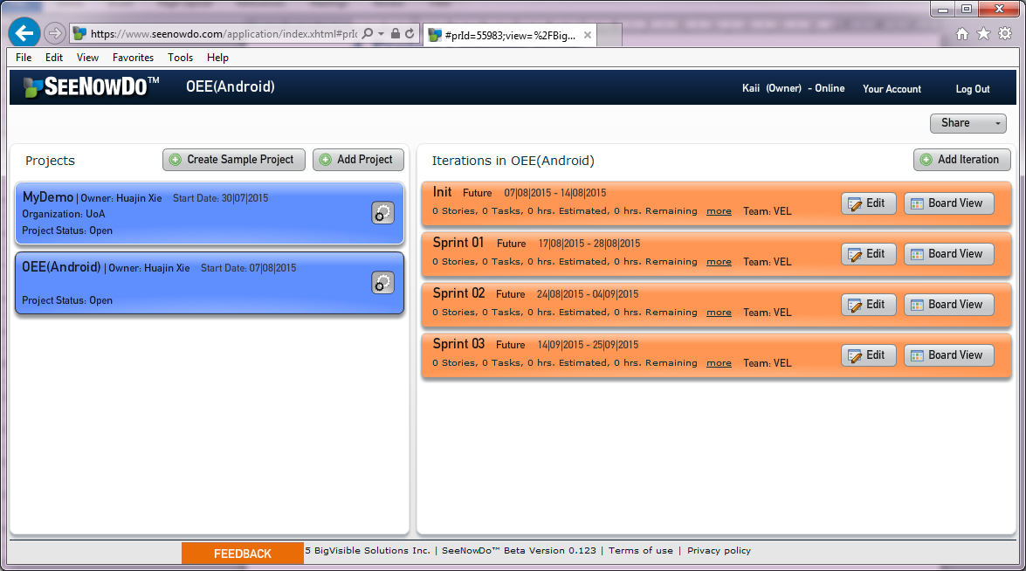
We can see our iterations (sprints),and if we chose the Board view we can see the detail an update our data.

- Image of user stories & Sprint Plan
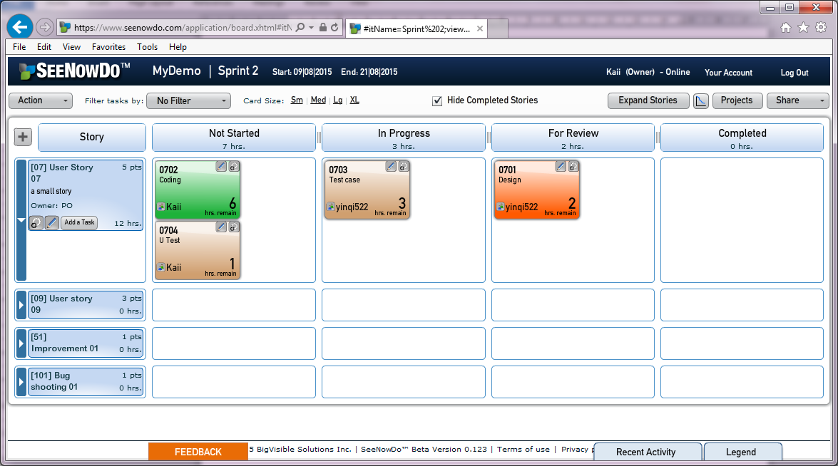
It likes a scrum board but it does not hang on a wall. Everyone can move tasks from one column to another column,and we can update the estimate of effort. Through the toll we can clearly know what other people are doing and the process of each task.

- Burn-down Chart
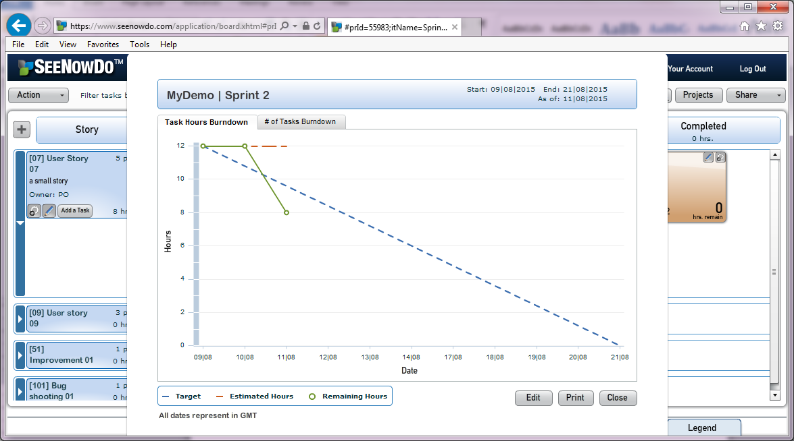
If we click the button “Iterationburn down”,it can generate a burn down char automatically.

